**Test Plan for a student Management system**

Test Plan Id Student_01_system

Project Name Student Management System

Prepared By QA Lead

Date 2-09-2025

Objective Ensure that the all Student, Admin, exam, fees and registration

Related functionality is fully functional with valid credentials

With Validations, Without making any kind of unexpected error

Or blocker of the function.For now the this application will take the

Load of 1000 student login at the same time.

Scope Any one can visit the Web site with the use of normal view

Student Login  
Registration  
admin Login  
Payment Gateway (For fees)   
Teacher Registration  
Student Ticket System (For books)

All this functionality should be work with the Validation

Out Of Scope Student Verification  
Admin Restrictions  
Course related uploading

Login through Advertisement

Reference Software Requirement Specification (SRS) Document

Data Flow Diagram (DFD)

Design Related Images or Document

Test Strategy we use the Kanban flow for the testing Process  
 Where we will use the To-Do list approach which will help

The developers to track their work status with easyness

Entry Criteria:

All the modules are correct in basic flow

-Dummy Student account is set to test the system

-Dummy books are created to test the library functionality  
 -Fake UPI Account are generated to test the payment module

-Fake Admin account are created with different rights so the testing

can be done through admin login also

-Testing Environment is ready for testing

-Tools for testing are Installed and set in Testing environment

-Unit Testing is done by developer so the further testing can be proceed

-Product is deployed in Testing environment

On Hold :

-If any kind of bug or error comes which block the further testing flow of the product

-If the middle module is not deployed in testing environment   
-at the time of the testing if the resources,environment or tester is not available

Resume :

When the bug or error solved which were blocking the further process of testing of the product

If missing module is deployed in testing environment  
If the problem is solved related to availability then the testing will   
Resume

Exit Criteria :

-All the bug of the product is solved

-There is not any other bug which will stop the flow of the product

-Test cases and bug report is correctly made and submitted to the QA Lead / Product Manager

Functional Testing **1.Login page**

-This module should be allow user with correct username and

Password

-If the wrong Username ,Password and both wrong is entered then

It should not allow the user to login and display proper error message

-Sql Injection like hacking method should not work here

-The forget password section should work correctly in the situation of user forget his/her login password

-Login button should able to enter when the login field have the data other it should be freezed  
-After 3 times of failed login the particular session or user should be blocked to access the system

**2.Registration page**

-The Student details should be correct according to the field

of the registration page

-If the user enter wrong data in the field then it should display error

Message

-There should be a defined format of the upload video or images related to his/her mark sheet or course

**3.Normal user Module**

-Any kind person can visit the website without the login to just view

The particular college environment, courses, fees structure , placement etc.

-The particular user didn’t access the any kind of restricted data which will only allow to a user when he/she login to the system

**4.Admin Module**

-This Module should only allow the admin username and password which is made by the admin

-The admin login have some of the super user rights that he can create, Read, update, delete the student data

-The admin login should have the teacher login so that it verify the student details and their performance

5.**Virtual Bank Module**

**-**Payment interface should be proper user friendly

-There should be the Payment facility that accept the fees of the

student which have to be integrated in the application in a secure

way

-The application have integrated UPI System which will allow the student to pay the fees with multiple options with security

-There should be the Transaction history page which records the

-Transaction related records with time stamp and reason of the transaction

-Check the PIN functionality it must have to be completely secure otherwise the payment system will be fail

6.**Books Ticket Module**

**-**Ticket modules for book should be accurate which

will note that which student have which book, for how many of days

-it should track the student return book date which and match the

actual return date

Non-Functional Testing Performance

-The system should be loaded in just 3 second

-In summer time if more than 1000 visits at the same time then the system should be work properly without making any slowness or

crash

Reliability

-The product should keep records with accurate data without

making any unnecessary updation

-The data should be match with student’s actual data

Availability

-The system should be available for 24/7/365

-The System should not be out of service after the college time

Security

-System should be fully secure that prevent unauthorized access to

The system

-Student information should not be leaked to the any kind of illegal website or any kind of fraud sites

Maintainability

-If any kind of the problem occur then it should be resolve as

possible time (Immediately)

Portability

-The system should be run in any kind of system without making any

kind of changes to the device

Test Environment Windows 11 with 8 Gb Ram , Linux with updated system,

Chrome with its recent updates, 320 K/Bs to 1 MB network speed,

Microsoft edge version 35+, Safari version 67+,Mobile devices and

desktop sites

Deliverables Test documents

Test Cases

Bug Report

Test Closer report

Defect management life cycle In the defect management life cycle we will use the simple

Defect management lifecycle flow which will help the entire team to

follow easily

We will use the following flow for the defect management

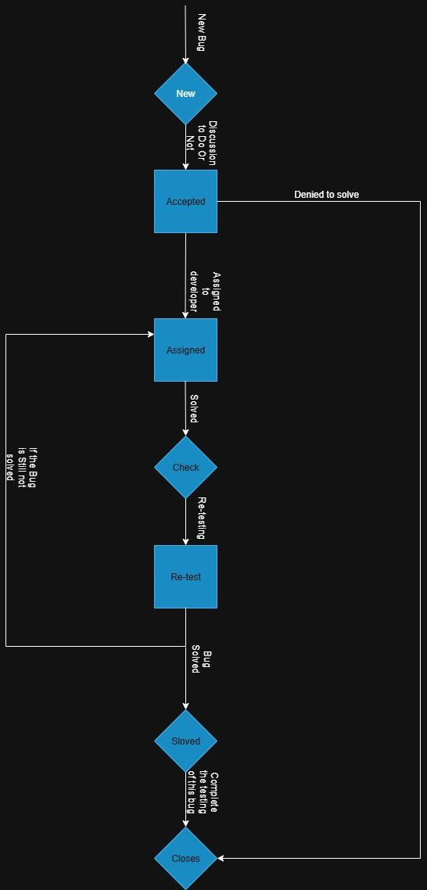

Roles &

Responsibilities QA team: Test the Modules with Test Case, recheck the solved Bug

QA Lead/Manager: Approval of the test plan and further test cases

Reviewing the test closer report

Developer: fixes the Bug and checking the Bug Uploaded is Valid or

Invalid

Test Schedule

|  |  |  |  |  |
| --- | --- | --- | --- | --- |
| Test Schedule | From date | To Date | Approval by | Designation |
| Requirement understanding | 04-09-2025 | 05-09-2025 | Ravi Nahak | Document head |
| Test Case designing | 06-09-2025 | 08-09-2025 | Dhruv Patel | QA Lead |
| Test case execution | 09-09-2025 | 12-09-2025 | Hiren Patel | QA Manager |
| Re-Test the Uploaded Bug | 13-09-2025 | 16-09-2025 | Deeepak Nahak | Supervisor |
| Test Closer report | 17-09-2025 | 19-09-2025 | Ketan Parab | Product Manager |

Risk and Mitigation Risk: This system is made for particular client so other college can’t

Access this system

Mitigation: After completion the system we can make the system

For multiple client

Risk: if the Student didn’t pay the fees then he will not notified about it

Mitigation: we can add the feature that the fees notification will automatically send to their parents and student itself too after declaration of fee schedule from college

Risk: If the amount of student login will increase suddenly then it will effect the system resources

Mitigation: after the release we will make the system scalable as much possible

Quires What if the student didn’t return the book on time ?

What if the Student payment failed at last date of the fee payment ?

What if a student want a book but the library don’t have ?

the book or the book is already issued to other student ?

What if the system will be used on Tab so how it’s UI and

Functionality will be done ?

Approval

|  |  |  |
| --- | --- | --- |
| Name of person | Date of approve | Designation |
| Hiren Patel | 02-09-2025 | QA Manager |
| Dhruv Patel | 02-09-2025 | QA Lead |
| Ketan Parab | 03-09-2025 | Product Manager |